The University of Azad Jammu and Kashmir, Muzaffarabad

Name :Alishba Zakir
Roll No: 2024-SE-02
Course: Computer Networks
Course Code: SE-2203
Lab# 2
Submitted To: Engr. Dr. Asma Javaid
Submitted By: Alishba Zakir
Date : 4 Mar, 2026

Department Of Software Engineering
Step1 : Exploring Packet Tracer
he bottom control panels of Cisco Packet Tracer occupy most of the frame:
- Network Component Box (Bottom-Left): The "Network Devices" category is selected (shortcut shown as Ctrl+Alt+R). Below it, specific device types like Routers are highlighted, displaying an array of models available for use (such as ISR4331, 1941, 2901, and 2911).
- Simulation and PDU Controls (Bottom-Right): This panel displays user scenario options ("Scenario 0") along with action buttons like New, Delete, and Toggle PDU List Window used for managing data packets during network simulations.
- Realtime/Simulation Bar: A dark blue status strip shows the simulation elapsed time (Time: 00:01:05) along with play and fast-forward controls.

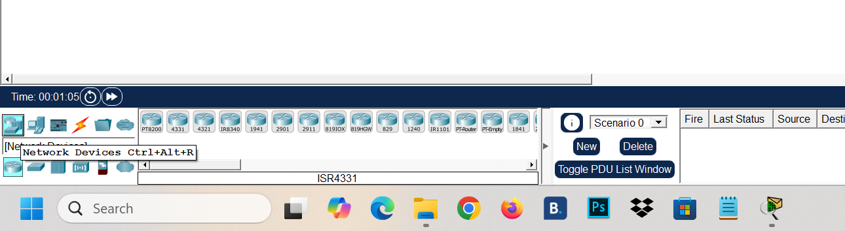
Step 02: Understanding IP Address Configuration :
PC0 :
- IPv4 Address: 192.168.1.1
- Subnet Mask: 255.255.255.0 (Class C network)
- Default Gateway / DNS: Set to 0.0.0.0 (Unconfigured)
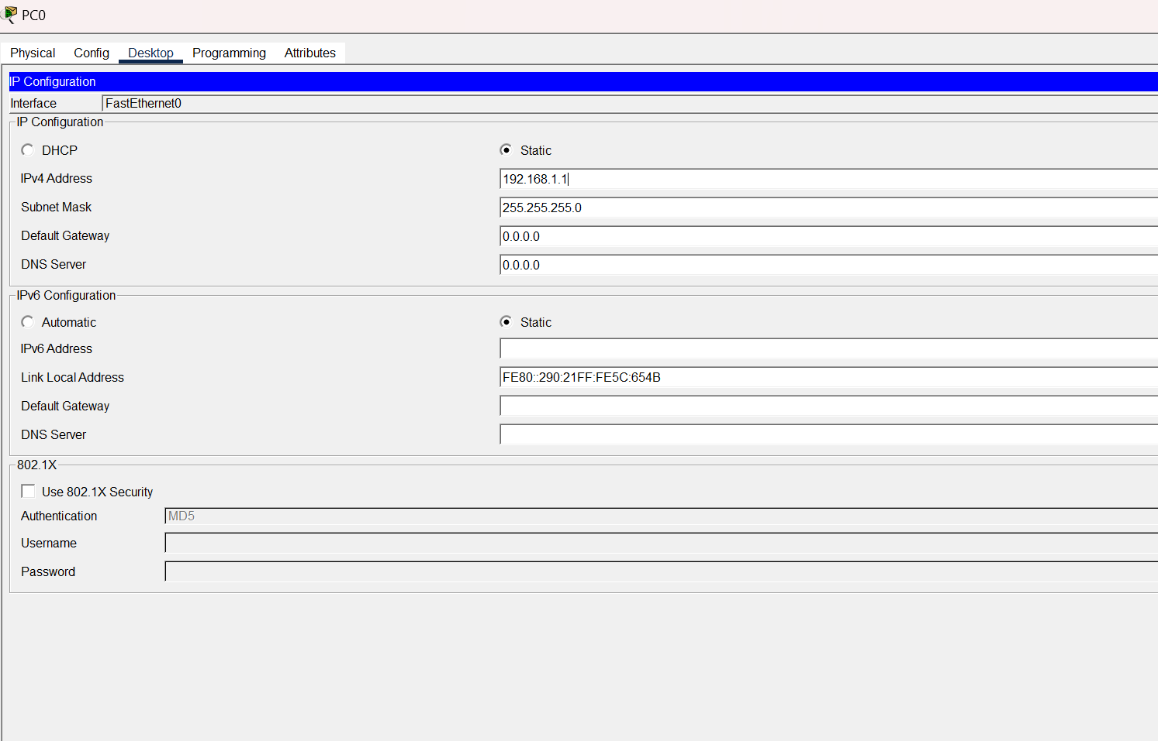

- PC1 (Second Image):
  - IPv4 Address: 192.168.1.2
  - Subnet Mask: 255.255.255.0
  - Default Gateway / DNS: Set to 0.0.0.0 (Unconfigured)
Purpose
This basic setup allows PC0 and PC1 to directly communicate and ping each other through a switch or a direct cable, as they share the same subnet (192.168.1.0/24). However, they cannot communicate outside their local network yet because no Default Gateway address has been specified.

